User Manual for StockGA Application

Introduction
This section explains the user operation of the StockGA application. First, the input file format is described. The input file holds shape information for all layouts, or tests, which are to be loaded in to the application at start-up. In the following section, an application snapshot and its visible features are presented. Next, the application menu items are covered.

Application Overview
StockGA processes layouts which are contained in the ‘shapes.txt’ input file. Each layout, or test, is an independent entity. When a test is initially displayed on the screen, the shapes defined in the test are laid out in the order found in the input file. If the layout requires more than one stock-sheet, the user can navigate through all sheets using the menu commands. Likewise, all layouts in the input file can be navigated using the menu commands.

By using the GA Settings dialog box, the user sets all parameters for running a GA experiment. To run the experiment, the ‘Run GA’ menu command is used. Whilst the GA experiment is running, status information including: number of generations processed and best and worst fitnesses in the population, are displayed in the output window. Once the experiment has finished, the evolved layout is displayed in the application window.

The layout currently on display in the application window can be exported to a text file (called layout.txt). All shape and location data, the total area used on each sheet and an overall fitness score are stored in this file.

Test Data File Format
Test data must be stored in a text file called ‘shapes.txt’. There is no limit to the number of tests that this file may contain. Each test is separated by white space, and the format to be used for each test is as follows:

<test-id> <shape-list> <test-description> <!> <regime> <sheet-width> <sheet-height>

All fields <> are delimited by white space. Table 1 describes the contents of each field.

<test-id> | A single string delimited by white-space which may contain up to 9 characters.
<shape list> | This field contains a list of shape specifications. Each specification contains an integer width, an integer height and a trailing comma (,). All specifications are separated by white-space. The last specification has a trailing colon (:). eg 2 2, 3 3, 4 4:
<test-description> | This field may contain up to 999 characters, including white-space. The exclamation (!) character must not be used in this field.
<!> | This field consists of a single ‘!’ character and must have white-space either side of it.
<regime> | This field must contain exactly one of the following (capitalised) labels:  { LEFTMOST ILEFTMOST TOPMOST ITOPMOST DYNAMIC }  This field sets the regime (or heuristic) used by the layout determining algorithm for placing shapes.
<sheet-width> | A positive integer which sets the width of a single stock-sheet.
<sheet-height> | A positive integer which sets the height of a single stock-sheet.
Table 1. Fields making up a single test in the input test file, ‘shapes.txt’. All shape and sheet sizes must be integer values.

An example consisting of three test entries:

1.1L) 20 10, 20 15: Force abutting in y-axis with previous ! LEFTMOST 30 30
1.2L) 20 10, 15 10, 20 10, 5 10: Force abutting in y-axis with previous and following ! LEFTMOST 30 30
1.3L) 20 10, 15 10, 20 10, 4 5, 5 5: Force abutting in y-axis with following ! LEFTMOST 30 30

Application Snapshots
The main application window is illustrated in Figure 1.

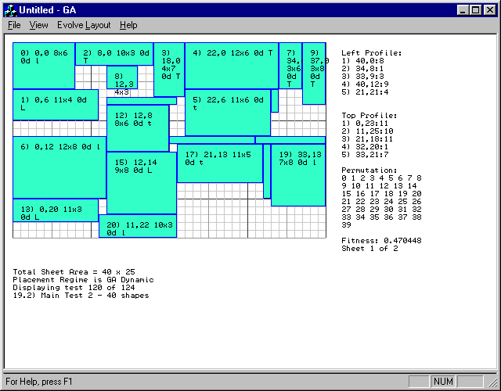
Figure 1. The StockGA Main Application Window.

The menu bar contains commands for manipulating the current layout, for running GA experiments, for navigating through sheets used in this layout, and for navigating other tests present in the test file.

The stock-cutting outline is placed on top of a grid which represents a single stock-sheet. The grid lines are drawn at unit intervals. Each placed shape has an annotation (which may not be visible if the shape is too small) which contains the following data: shape-id, coordinate of top-left vertex, dimensions of the shape, whether the shape is rotated 0 or 90 degrees, and a single character indicating the heuristic used to place the shape. For example, the top-left shape in the layout of Figure 1 has the following annotation:

0) 0,0 8x6 0d l,

In this example, the shape-id is zero, the coordinate of the top-left vertex is (0,0), the size of the shape is (8x6), the shape has 0 degrees rotation and the heuristic ‘l’ has been used to place the shape. Shape-ids are assigned to shapes in the order in which they are found in the test specification.

Heuristic Label | Full-name of Heuristic
L | LEFTMOST
l | ILEFTMOST (Inner leftmost)
T | TOPMOST
t | ITOPMOST (Inner Topmost

Table 2. Heuristic labels and their corresponding full names.

Edges specifications for edges in the left and top edge profiles are displayed in the order found in their respective list. An edge specification consists of an (x,y) coordinate (called the hotspot), followed by the length of the edge. For left profile edges, the hotspot is the top-most extent of the edge. For top profile edges, the hotspot is the left-most extent of the edge.

Other information displayed includes: the permutation of shapes that has been laid out; the overall fitness of the layout; the number of sheets the layout uses and the current sheet being displayed; the total sheet area; the placement regime used to place shapes; and test-id and test description information.

The output window (see Figure 2) displays status data pertaining to the latest GA experiment. This display is updated whilst the GA experiment is running. The fields from left-to-right are: number of generations evolved, fitness of best chromosome, fitness of worst chromosome and the number of ‘duplicate’ chromosomes present in the population. A ‘duplicate’ chromosome has a ‘similar’ fitness to the fittest chromosome. The ‘CM’ annotation denotes that the number of duplicates has exceeded a ‘threshold’ and that the population has been cataclysmically mutated. The definitions of ‘similar’ and ‘threshold’ are set in the GA Settings Dialog.

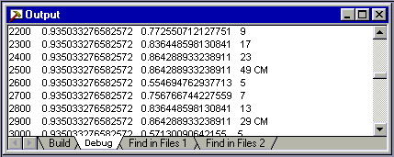
Figure 2. The StockGA Output Window.

Application Menu Commands
Menu commands having a keyboard-shortcut, have the shortcut in brackets after the command name.

File Menu

Export Layout (Alt+L)
The layout of all sheets for the test currently displayed in the application window is output to the ‘layout.txt’ text file. Figure 3 provides an example of the exported data.

Test performed: 09/07/98 15:09:50
Test 100 of 124
Test Description: 13.6T) Left placed shape masking edges 2,3,4 in top profile
Sheet Size = 30x30
Number of Sheets Used = 1

Fitness Report:
Sheet 0: Area Used = 25x30

Overall Fitness Of Layout: 0.475127

Formatted Output:
Col 1: S=New Sheet, -=No New Sheet
Col 2: Shape ID
Col 3: Rotation=0 or 90 Degrees
Col 4: Shape Size: (X-size x Y-size)
Col 5: Location: (X , Y)

S ID=0 R=0D 10x5 (0,0)
- ID=1 R=0D 5x5 (10,0)
- ID=2 R=0D 11x6 (0,5)
- ID=3 R=0D 6x3 (15,0)
- ID=4 R=0D 11x19 (0,11)
- ID=5 R=0D 4x4 (21,0)
- ID=6 R=0D 14x6 (11,5)
Figure 3. Typical layout information output to the ‘layout.txt’ file.

Print (Ctrl+P)
Outputs the contents of the application window to a connected printer. Only the currently displayed stock-sheet is printed. To print multi-sheet layouts, navigate through each sheet and print them individually.

Print Setup
Allows printer-specific parameters to be set.

Exit
Quits the StockGA Application.

View Menu

Refresh (Alt+R)
Reloads the ‘shapes.txt’ layout information file. This command is to be used after a modification has been made to the layout file whilst the StockGA application is running.

Normalise Chromosome (Alt+N)
Lays out the shapes for the current test in the order specified in the test file. This corresponds to a shape-id permutation of 0, 1, 2..., n-1, where n is the number of shapes in the test.

Shuffle Chromosome (Alt+W)
Lays out the shapes for the current test in a random order.

Order Chromosome (Alt+O)
Lays out the shapes for the current test in an order specified by the user. The order is specified as a list of non-negative integers in the range 0 to n-1, where n is the number of shapes in the test. The integer list is verified for being a valid permutation.

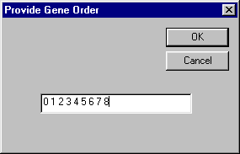
Figure 4. Dialog Box invoked when the Order Chromosome menu command is invoked.

Next Test (Alt+X)
Updates the application window with the layout and test information corresponding to the test following the test currently displayed.

Previous Test (Alt+Z)
Updates the application window with the layout and test information corresponding to the test preceding the test currently displayed.

Next 10th Test (Alt +D)
Changes the current test to the test which is the tenth test following the current test.

Previous 10th Test (Alt+A)
Changes the current test to the test which is the tenth test preceding the current test.

Goto Test... (Alt+G)
Changes the current test to a test specified by the user. Tests are identified by their position in the test file.

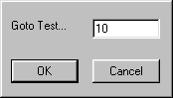
Figure 5. Dialog Box invoked when the ‘Goto Test’ menu command is invoked.

View Next Sheet (Alt+0)
Updates the display to show the next sheet for the current layout.

View Previous Sheet (Alt+9)
Updates the display to show the next sheet for the current layout.

Set Regime For This Test (Alt+T)
Allows the user to change the regime used for laying out shapes in the current test. The change is retained until the test file is reloaded using the ‘Refresh’ menu command.

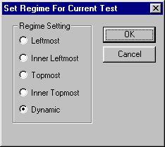
Figure 6. Dialog Box invoked when the ‘Set Regime’ menu command is invoked.

Evolve Layout Menu

GA Settings (Alt+S)
This command invokes the dialog in Figure 7.

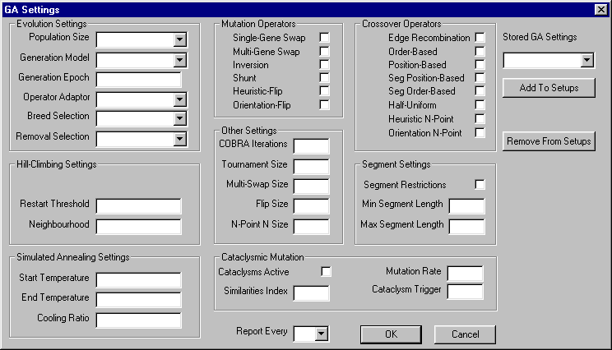
Figure 7. GA Settings Dialog Box used for configuring all GA experiment parameters.

Parameter | Possible Values
Population Size | 50 | 100 | 150 | 200
Generational Model | Steady-State GA | Hill Climbing | Steepest Ascent Hill Climbing | Simulated Annealing
Generation Epoch | Positive Integer Value – Number of generations to evolve
Operator Adaptor | Adaptive Mutation | COBRA | Fixed Rate | Random
Breed Selection | Rank | Tournament
Removal Selection | Least-Fit | Inverted Rank
Table 3. Summary of values that evolution settings can have.

Settings Group | Parameter Name | Purpose
Hill Climbing Settings | Restart Threshold | If fitness is not improved after this no. of hill-climbing iterations, then the current solution is randomised.
Hill Climbing Settings | Neighbourhood | Number of samples to taken at each hill-climbing iteration in Steepest Ascent Hill Climbing
Simulated Annealing Settings | Start Temperature | Initial value that current temperature is set to
Simulated Annealing Settings | End Temperature | Value for current temperature that terminates SA
Simulated Annealing Settings | Cooling Ratio | Current temperature is multiplied by this factor at each iteration of SA
Segment Settings | Segment Restrictions | When selected, restricts segment crossover operators to segment lengths between Min and Max values.
Segment Settings | Min Segment Length | Minimum gene-length that segment crossover operators act upon
Segment Settings | Max Segment Length | Maximum gene-length that segment crossover operators act upon
Cataclysmic Mutation | Cataclysms Active | When selected, enables cataclysmic mutation
Cataclysmic Mutation | Similarities Index | Ranged between 0 and 1 – determines how close a chromosome has to be in fitness to the best chromosome before being counted as a duplicate
Cataclysmic Mutation | Cataclysms Trigger | Number of duplicates in the population that triggers cataclysmic mutation
Cataclysmic Mutation | Mutation Rate | Ranged between 0 and 1 – determines percentage change made to all chromosomes except the best one, when cataclysmic mutation takes place
Other Settings | COBRA Iterations | Number of times that a COBRA rate adaptor may apply genetic operators at random to determine their relative usefulness
Other Settings | Tournament Size | Number of chromosomes to be considered when tournament selection is used
Other Settings | Multi-Swap Size | Number of pairs of genes to swap in multi-swap mutation
Other Settings | Flip Size | Number of genes to mutate every time orientation mutation or heuristic mutation is used
Other Settings | N-Point N Size | Number of crossover points to use in orientation n-point crossover and heuristic n-point crossover
Table 4. Summary of GA Settings Dialog parameters

Table 3 and Table 4 summarise the parameters that affect how the GA experiment runs. In addition to these, there are check-boxes that allow the user to select which mutation and crossover operators to use. The ‘Report Every’ parameter determines how often the GA reports its current status. The type of experiment is determined by the Generational Model parameter. The Steady-State value for this parameter enables a GA to run. All other settings cause a stochastic experiment to run, such as Hill Climbing.

The ‘Stored GA Settings’ parameter provides a method for saving all current GA Settings in a file for future use. To enable this function, a name is entered into the ‘Stored GA Settings’ drop-down list-box and the ‘Add to Setups’ button is clicked. Previously stored setups appear in the drop-down box. The ‘Remove From Setups’ button allows setups to be erased. Setups are saved when the GA Settings Dialog is closed using the OK button. If the CANCEL button is clicked then any newly defined setups are not stored to disk. Setups are stored in a binary file called ‘setups.bin’.

Certain sets of parameters are disabled depending on which Generational Model is selected. For example, only the Steady-State Generational Model uses crossover operators. Figure 8, Figure 9 and Figure 10 show how the GA Settings dialog appears for different Generational Model settings. Ghosted parameter fields are not active.

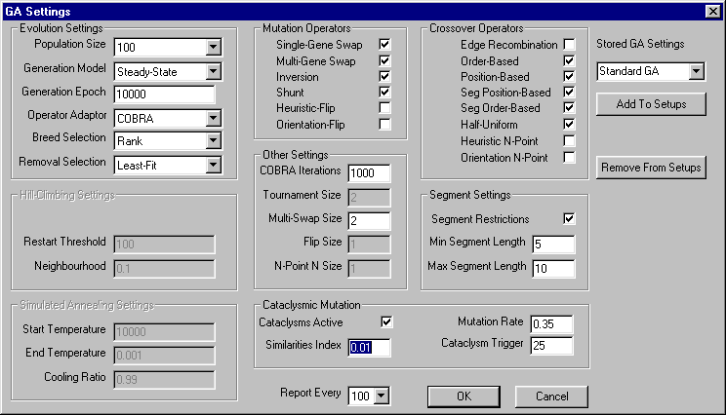
Figure 8. GA Settings Dialog status when Steady-State is selected

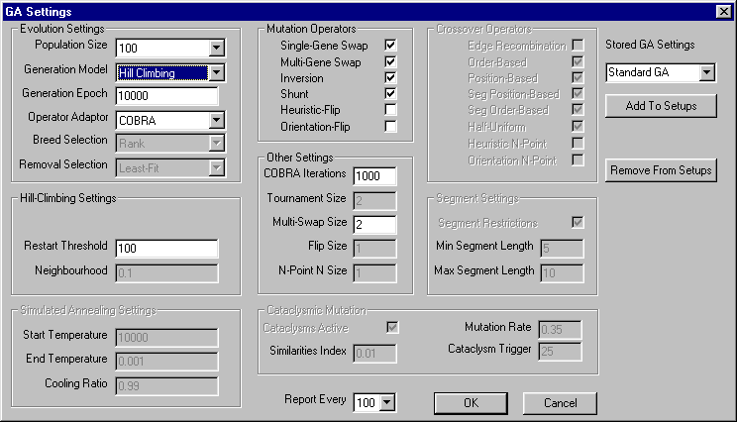
Figure 9. GA Settings Dialog status when Hill Climbing is selected

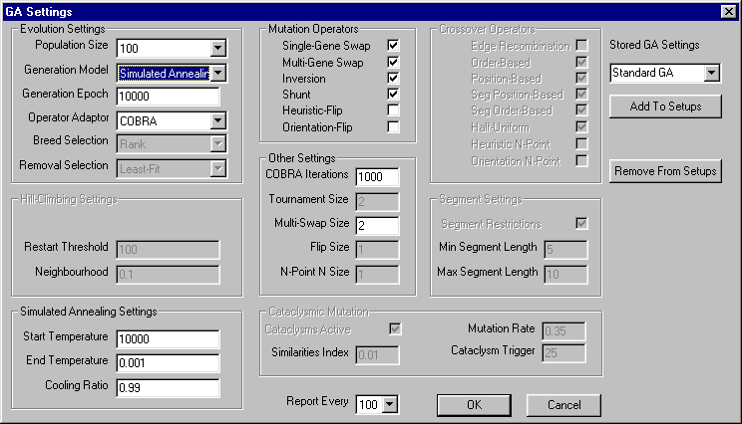
Figure 10. GA Settings Dialog status when Simulated Annealing is selected

Run GA (Alt+E)
This command runs the GA experiment using the parameters set in the GA Settings Dialog. Current status, throughout the experiment, is reported in the output window. After the experiment has concluded, the fittest chromosome has its layout displayed in the application window. Figure 2 illustrates the output window. Layout data can be written to disk using the ‘Export Layout’ command.

Help

About GA...
Displays a dialog box that summarises the use of the StockGA application.

